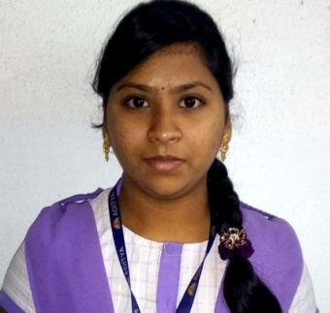**Name:**santhoshi

**Contact No:**7288026271

**Email ID :**karrisanthoshi1234@gmail.com

|  |
| --- |
| **CAREER OBJECTIVE** |
| Looking for a challenging role in a reputable organization to utilize my skills and to obtain professional and financial heights, both for the organisation and self, through skill and knowledge and learn from presents as well as establishment also. |
| **ACADEMICS** |
| |  |  |  |  |  | | --- | --- | --- | --- | --- | | DEGREE | NAME OF THE INSTITUTE | CGPA/PERCENTAGE | PLACE | YEAR | | B.TECH  [cse] | ADITYA ENGINEERING COLLEGE | 7.64 | SURAMPALEM | 2021 | | XII | ADITYA JUNIOR COLLEGE | 88% | MANDAPETA | 2017 | | X | SRI CHAITANTA TECHNO SCHOOL | 8.2 | MANDAPETA | 2015 | |
| **INTERNSHIPS & PROJECTS** |
| * **Project/Internship 1:**Machine learning with python & IBM Watson * **Project/Internship 2:**Brain tumor detection using MRI images |
| **TECHNICAL SKILLS** |
| * **Web technologies :** HTML,PHP * **Database :** MYSQL * **Known Programming Languages:**c,java,python |
| **ACHIEVEMENTS** |
| * GOT CERTICATE FROM **NPTEL** FOR COMPILETION OF **PYTHON FOR DATA SCIENCE** AND **FOUNDATION TO COMPUTER SCIENCE** COURSES. * GOT CERTIFICATE ON **PYTHON** FOR ONE-DAY HANDS-ON WORKSHOP. * GOT COURSE COMPLETION CERTIFICATES ON **WEB DEVELOPMENT,ARTIFICIAL** **INTILLIGENCE** IN MYCAPTAIN. |
| **PERSONAL DETAILS** |
| * **Date of Birth :** 23/03/2000 * **Father’s Name :** karri subba reddy * **Mother’s Name :** karri sujatha * **Current Address :** 6-22/1,pedha nuthi street,   Arthamuru,Mandapeta Mandal,  East Godavari District,533340   * **Permanent Address :**  6-22/1,pedha nuthi street,   Arthamuru,Mandapeta Mandal,  East Godavari District,533340   * **Hobbies :** Social Networking,   Team Sporting,  Passionate about work   * **Nationality :** Hindu/Indian * **Languages Known :** English,Telugu * **Any kind of disability :** No * **Willingness to Relocate :** Yes |
| **DECLARATION** |
| **I hereby declare that all the above-mentioned information is true and correct to the best of my knowledge.** |
| **Place :** surampalem  **Signature/E-signature:santhoshi** |

**10TH CERTIFICATE:**

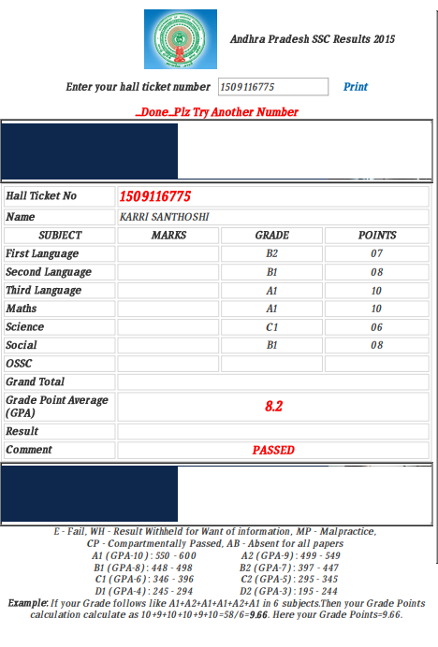

**INTER CERTIFICATE:**

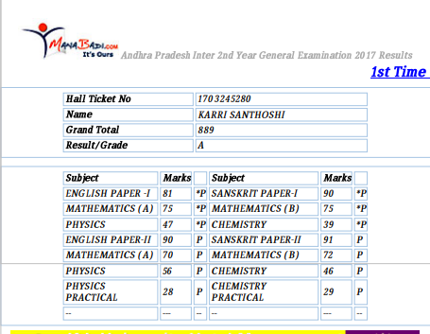

**BTECH SEMESTER EXAM CERTIFICATES:**

**1ST SEMESTER:**

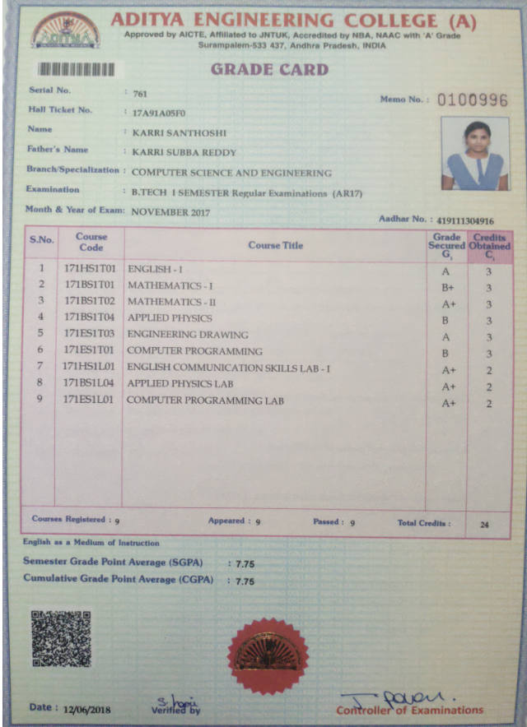

**2ND SEMESTER:**

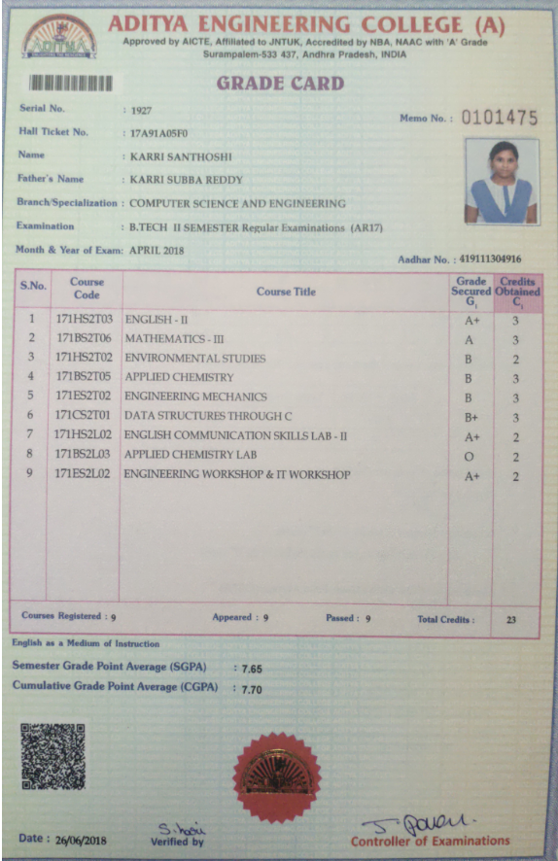

**3RD SEMESTER:**

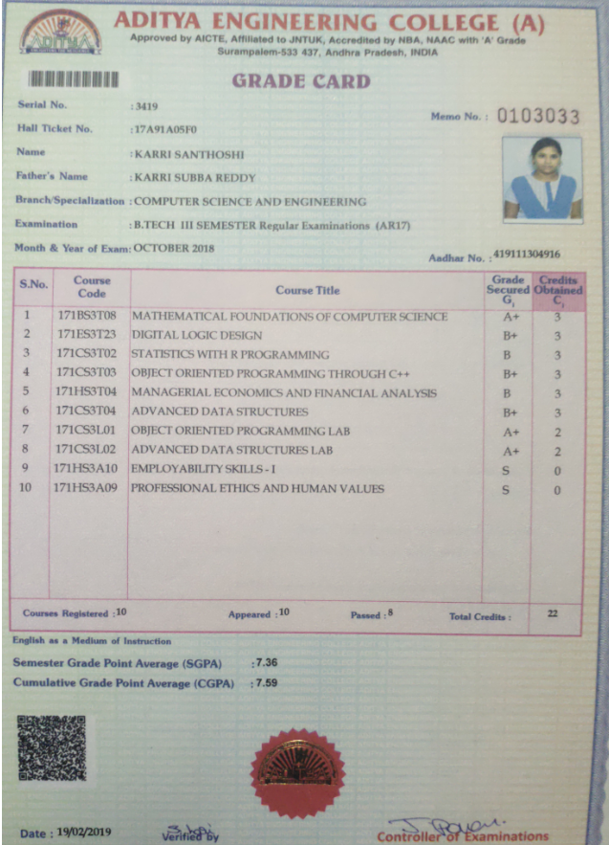

**4TH SEMESTER:**

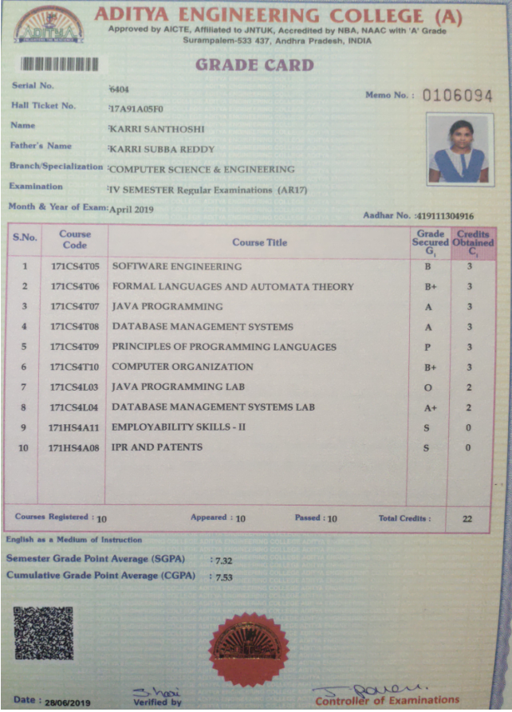

**5TH SEMESTER:**

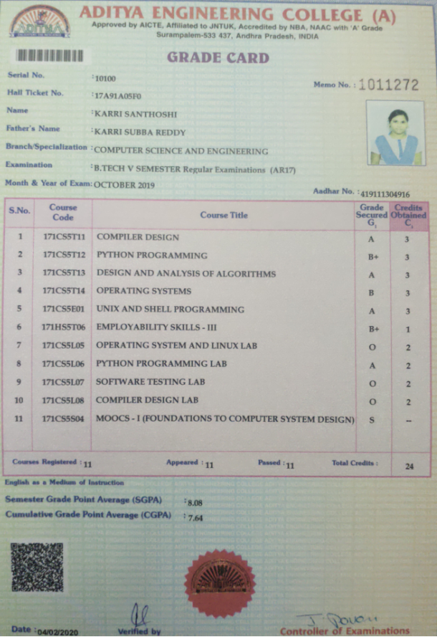

**AADHAR CARD:**

